**Last updated on 6/27/25

**SBNC supplies are stored at Budget U-Stor, Unit #3  
Location: 130 Garden Street**

(at the corner of Garden St & Yanonali St; the building faces Yanonali St)

**Hours: M-F, 8:30 AM - 5:30 PM Weekends: 9:00 AM - 5:00 PM**

**Navigating the Storage Unit:**

* The unit is located on the first floor.
* You will need to sign in at the reception desk.
* After signing in, turn around walk down the hall, and then make a left.
* As you turn left, turn the light switch timer clockwise to turn on the hall light.
* Hand trucks are available and are parked near the office.
* Ask the office manager on duty if you need help.

**Opening the Storage Unit:**

* Enter the **code 1956** on the bottom of the lock.
* **To unlock:** Squeeze the top of the lock and the bottom together, and the lock will open. A person holding a lock

  AI-generated content may be incorrect.
* **To lock:** Scramble padlock numbers. Then squeeze top and bottom to engage the lock.

**Using the Log Sheet System:**

* Located in the center of the locker, write your committee name, your name & phone Number – so you can be contacted, if needed. List the items being borrowed and the quantities, and the date they are checked out.
* Please return items promptly after the event.
  + Glassware and other items used for food/drink should be returned clean and dry.
  + Linens should be returned laundered, if necessary.
  + Please return items to the storage bins or shelves where they were found.
* Find your check-out entry on the Log Sheet and enter the date the items were returned.
* Questions? Contact: [memberatlarge@sbnewcomers.org](mailto:memberatlarge@sbnewcomers.org)

| **Item** | **Qty** | **Comment** | |
| --- | --- | --- | --- |
| **Table Linens – see photo 3** | | | |
| **WHITE - ROUND** |  | **BURGUNDY - ROUND** |  |
| 90” (7.5 ft) | 4 | 90” (7.5 ft) | 19 |
| 96” (8 ft) | 2 | 52” (4.5 ft) | 1 |
| 108” (9 ft) | 18 | **BURGUNDY - RECTANGLE** |  |
| 120” (10 ft) | 15 | 60” x 84” (5 X 7 ft) | 1 |
| 122” | 1 | **BURGUNDY - RUNNERS** | 2 |
| 126” (10.5 ft) | 2 |  |  |
| **WHITE - SQUARE** |  | **GREEN - RECTANGLE** | 1 |
| 48” (4 ft) | 2 | **GREEN - SQUARE** | 1 |
| 120” (10 ft) | 1 | **GREEN - RUNNERS** | 2 |
| **WHITE - RECTANGULAR** |  | TABLE LINENS can be found in black plastic storage bins stored along the back wall. | |
| 60” x 96” (5 X 8 ft) | 14 |
| 60” x 126” (5 X 10.5 ft) | 11 |
| 90” x 132” (7.5 X 11 ft) | 19 |
| **WHITE - NAPKINS** | UNK |
|  | | | |
| **Glassware – see photos 4 & 5 for locations** | | | |
| Wine glasses, 12 oz. | 212 | Acopa Select Flora 12 oz. wine glass; bought at webrestaurantstore.com | |
| Wine glasses, over sized | 23 |  | |
| 10-glass wine glass racks | 20 | Cambro 10HS800151 Soft Gray Camrack 8 1/2" Half Size with 4 extenders; bought at webrestaurantstore.com | |
| Champagne flutes | 40 |  | |
| Shot glasses | 47 |  | |
| Margarita glasses (plastic) | 13 |  | |
| Wine carafes | 4 |  | |
| Wine bottle openers (Wing type corkscrews) | 2 |  | |
| Foil cutters | 4 |  | |
| 2 oz. pourers | 12 | Hand wash only! | |
|  | | | |
| **Serving Items – located in photo 2, unless otherwise noted** | | | |
| Large metal chafing dishes w/ Sterno holders & foil pans | 4 | Located on left – photo 2 | |
| Disposable foil chafing dishes w/ metal stands & foil pans | 3 | Located on left – photo 2 | |
| Chafing dishes – 8 quart capacity | 2 | Located on left – photo 2 | |
| Warming tray – 24”x16” | 1 | Located back left – photo 2 | |
| Coffee Urn – 45 cup capacity | 1 | Located back left – photo 2 | |
| Chocolate fountain | 1 | Located back left – photo 2 | |
| Water servers (fruit / veggie flavor able) | 4 | Located left in photo 2 | |
| Plastic pitchers for water / soda / beer | 24 | Located left in photo 2 | |
| Various small & medium bowls | 20 | Located left in photo 2 | |
| Giant salad bowls (can also use as ice buckets) | 2 |  | |
| Serving trays (round, oval, and rectangular) | 12 |  | |
| Tubs (large, black) | 2 | Located in center – photo 3 | |
| Ice bucket (clear plastic) | 2 | Located in center – photo 3 | |
| Galvanized metal drink tubs, large, round | 2 | Located in center -- use 33 gal liner | |
| Oval ice tub, 18 liter (translucent plastic) | 4 | Manufacturer: Zilpoo on Amazon | |
| Wine glass appetizer/cocktail plates (acrylic, square) | 90 |  | |
| Wine glass appetizer/cocktail plates | 29 | Located in photo 5 | |
| Plastic dinner plates | 12 | Located in photo 5 | |
| 10” Pastel plastic dishwasher safe plates | 150 | Located in photo 5 | |
| Colored plastic dinner plates | 42 | Located in photo 5 | |
| "Corelle" type white plates | 30 | Located in photo 5 | |
| Metal butter knives | 16 | Located in photo 5 | |
| Metal forks | 24 | Located in photo 5 | |
| Various metal & plastic serving utensils (tongs, spatulas, spoons, etc.) | lots | Located in photo 5 | |
| Lobster cracker & fork sets | 18 | Located in photo 5 | |
| Assorted paper products (plates, napkins, cups) & plastic utensils | lots | Located in photo 5 | |
|  | | | |
| **Electronics (photo 4 along right back wall, unless otherwise noted)** | | | |
| Epson PowerLite model 1286 projector, 1920 x 1280 resolution | 1 | S/N X4JK8100193 | |
| Epson model VS220 projector 800 x 600 resolution | 1 |  | |
| Projection screen | 1 |  | |
| Microphone/speaker | 1 | Upper left shelf – see photo 1 | |
| Voice amplifier | 1 | Contact Local Heritage | |
| Extension cord, 25' | 1 |  | |
| JBL speaker and microphone | 1 | Stored in center – see photo 3 | |
|  | | | |
| **Decorations / Games / Party Props (back wall and back right corner – photos 3 & 4)** | | | |
| Glass cylinder vases, 12" | 18 |  | |
| Round flared vases, 8" | 5 |  | |
| Glass tea candle holders | 12 |  | |
| Sombrero | 1 |  | |
| Mexican blankets | 14 |  | |
| Poker sets (cards, chips in aluminum cases) | 2 |  | |
| Bedazzled western-style bandanas | 12 |  | |
| Place card holders | 12 |  | |
| Chinese related- lanterns, hats, monkeys |  |  | |
| 1960 décor- album covers, ouija board, hula hoop, Indian print bedspread, etc. | All |  | |
| Roll of tickets |  |  | |
| Photobooth props | Bag |  | |
| Pinwheels | 16 |  | |
| Metal flowerpots | 20 |  | |
|  | | | |
| **Miscellaneous** | | | |
| Newcomers A-frame signs | 12+ | Instant Sign Company, contact: lee@instantsignsb.com | |
| Grey ice chest w/ wheels, XL | 1 |  | |
| Red ice chest, XL | 1 |  | |
| Ice chests, Med | 1 |  | |
| Plastic tubs, large yellow | 2 |  | |
| Tables that fold in half, 6'L x 30"W | 3 |  | |
| Folding chairs | 9 |  | |
| Marborg cardboard trash boxes | 6 | Use Marborg liners | |
| Round collapsible trash bins | 7 | Use 33 gal liner | |
| Office supplies (12 small clipboards, pencils, pens, Sharpies, scissors, etc.) | Lots |  | |
| Avery 5395 name badges |  | Printable labels to be used for registered events (ie sponsored home events and Heritage committee) | |
| Avery 5163 name badges |  | Sharpie write capable labels to be used for less formal events, such as TGIF | |
| White E-Z Up pop-up tent 10’x10’ with weights | 1 | Far back right corner of locker – note that weights are 10 lbs each | |
| 2’x4’ Easel pad with Post it working flip charts for committee brainstorming as well as event queue facilitation | 1 | Center of room | |
| Folding utility wagon (center of locker) | 1 | Mfgr: Mac Sports. Inside dimensions: 32.5"L x 17.5"W x 10.5"H | |

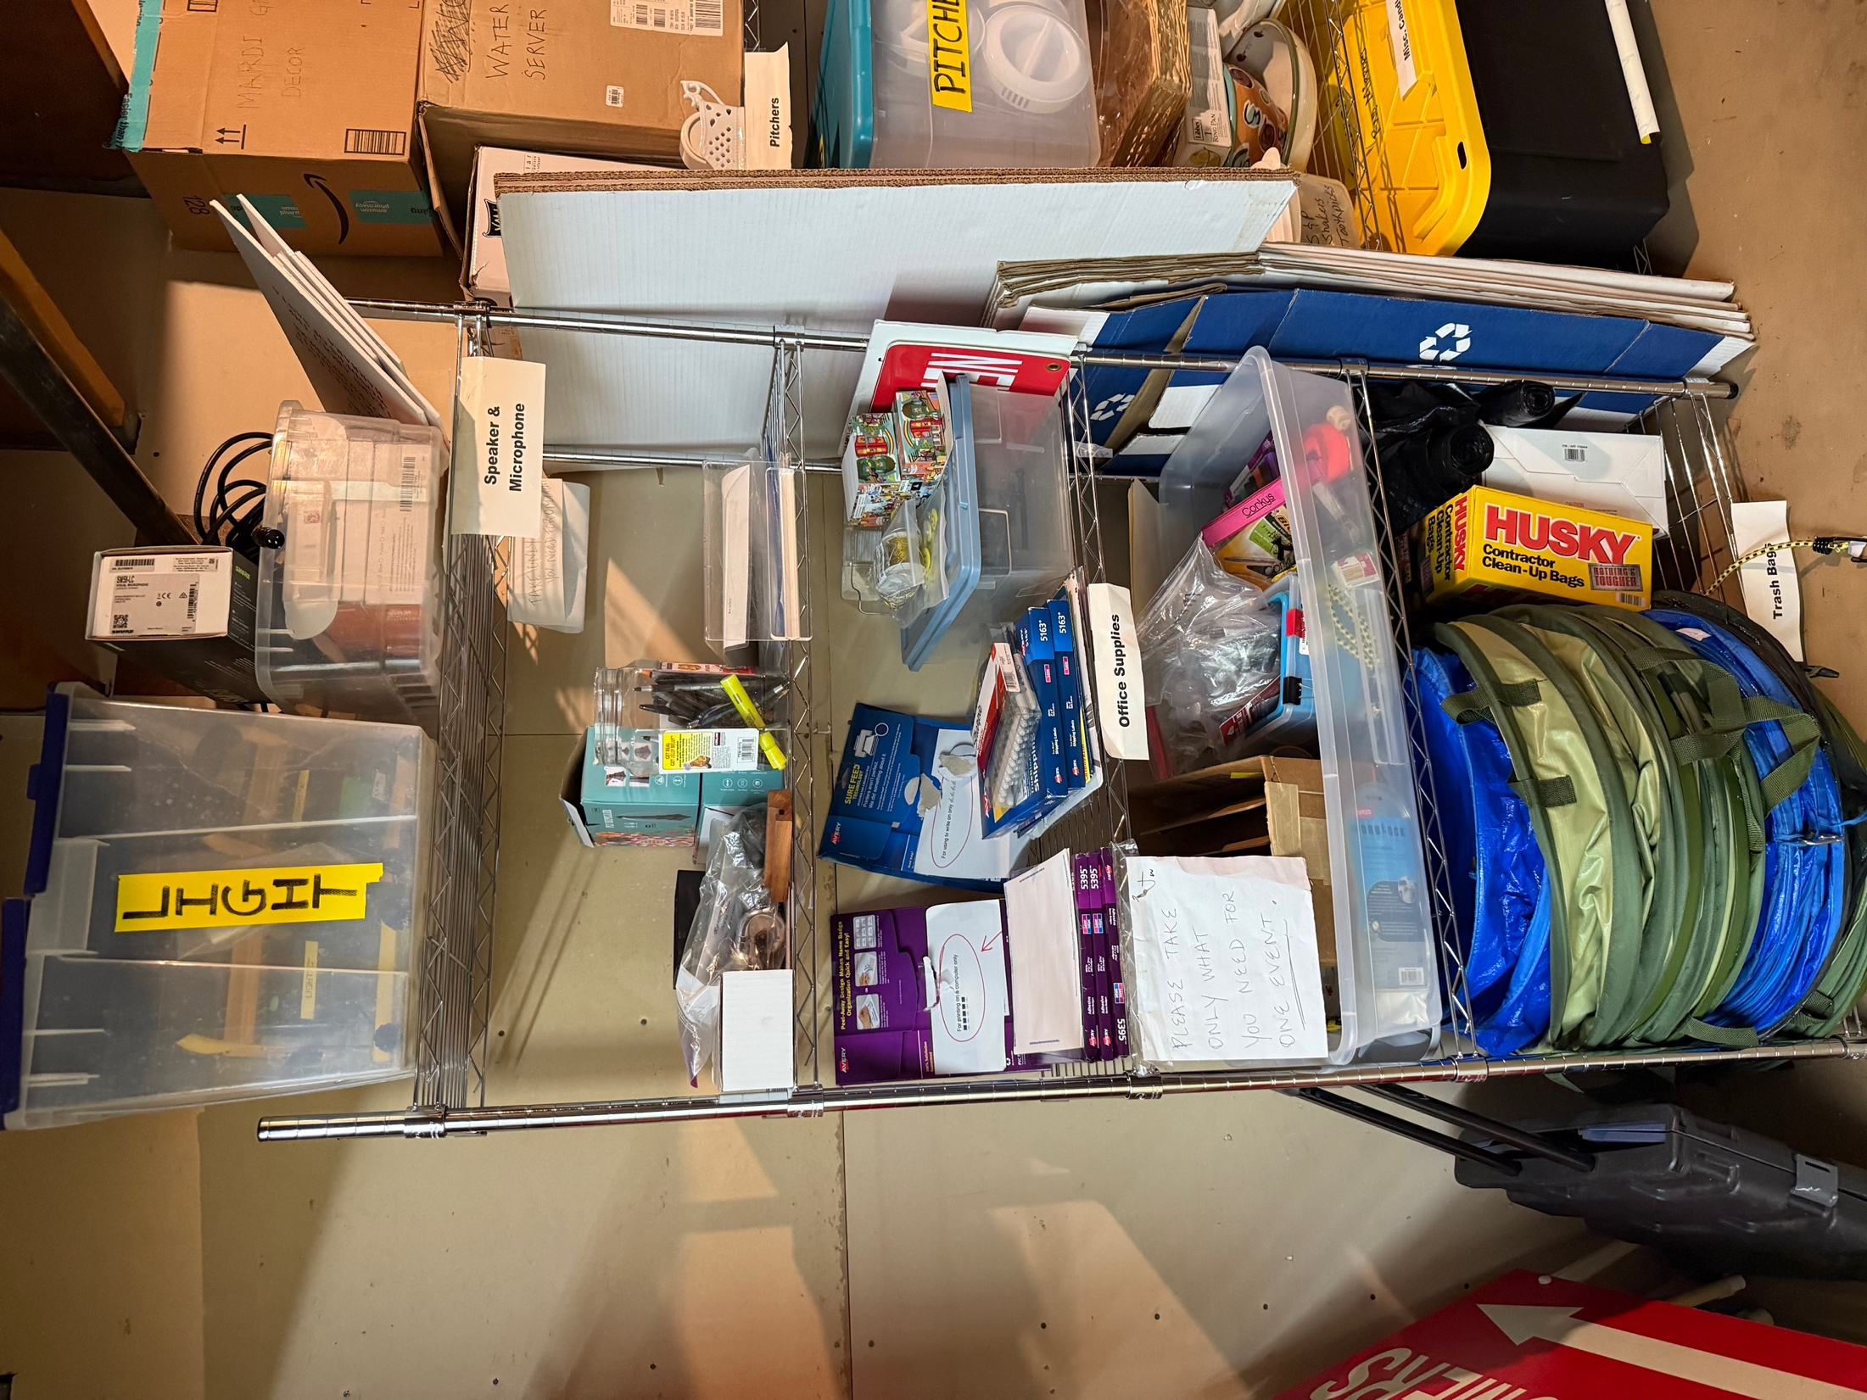

**GARBAGE CANS**

& garbage bags

**NAME TAGS**

*Note different types for hand-written or printer

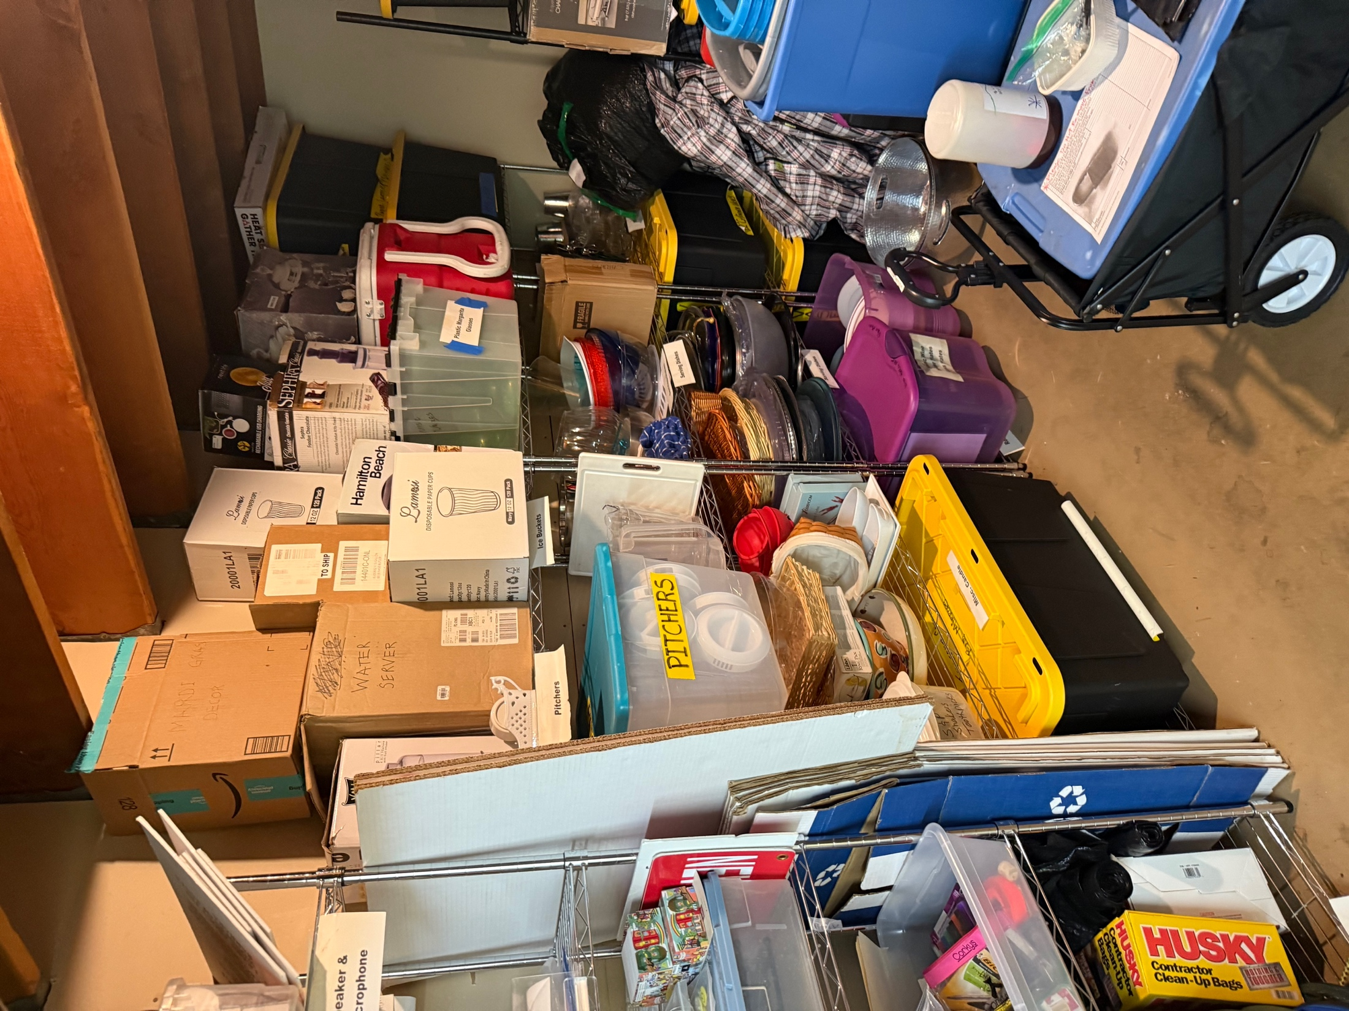

**SERVING ITEMS**

Platters, baskets, bowls, pitchers, urns, paper coffee cups

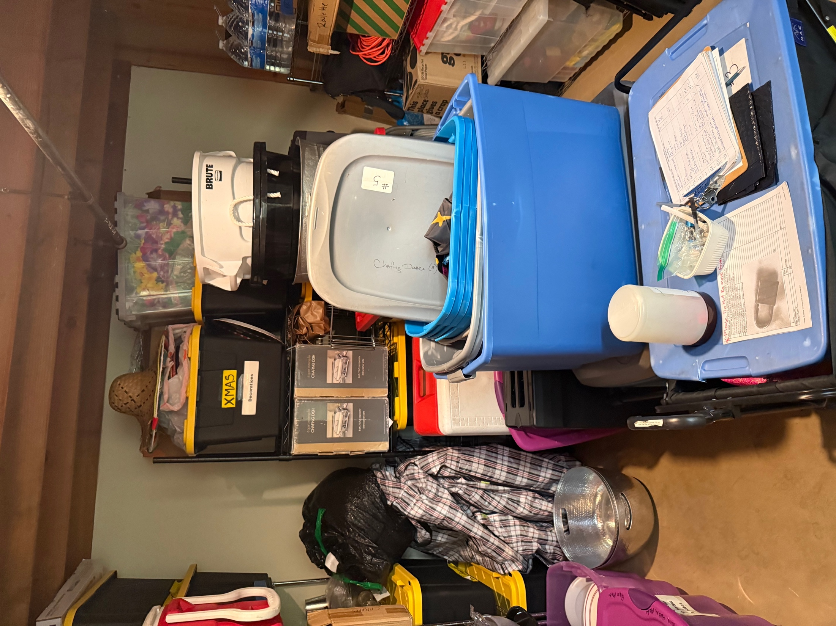

**COOLERS**

and ice buckets

**ELECTRONICS**

*Note microphone and speakers above name tags

**PARTY SUPPLIES** games & decorations

**Decorations**

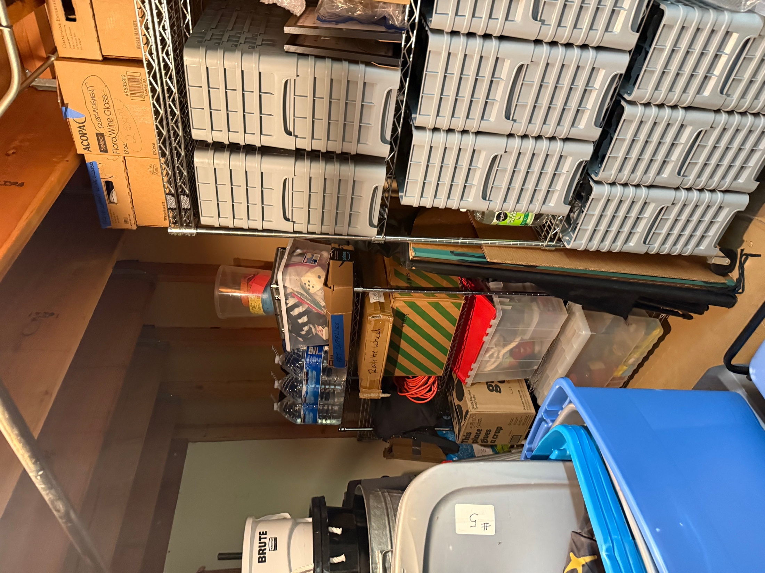

**Folding chairs**

**White board and easel**

**Wine glasses**

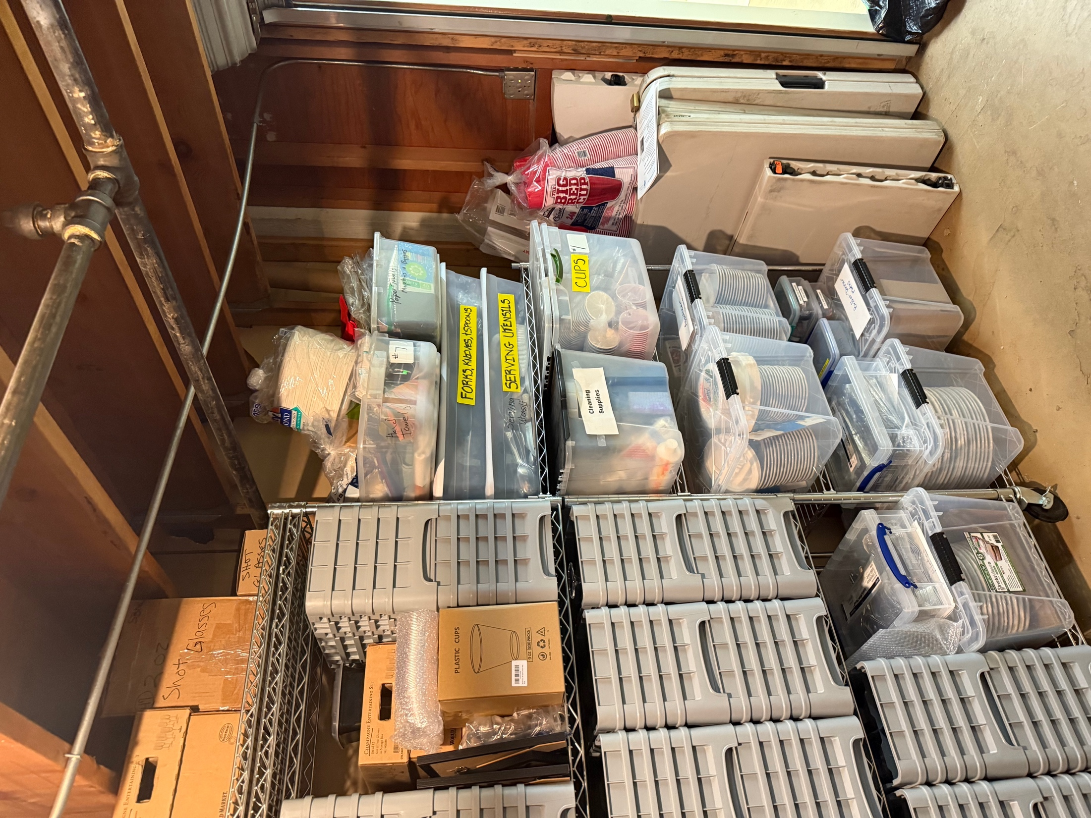

**DISHES & UTENSILS**

& cups, napkins, etc

**Folding tables**